**[STEP#1]** kubectl apply -f https://raw.githubusercontent.com/kubernetes/dashboard/master/aio/deploy/recommended/kubernetes-dashboard.yaml

**[STEP#2]** kubectl proxy

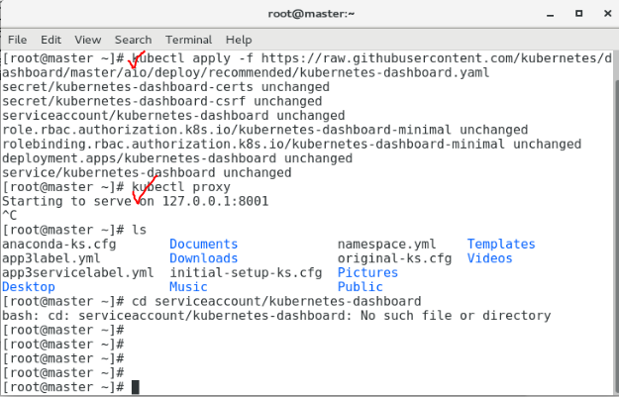

**[STEP#3]** On visiting http://localhost:8001/api/v1/namespaces/kube-system/services/https:kubernetes-dashboard:/proxy/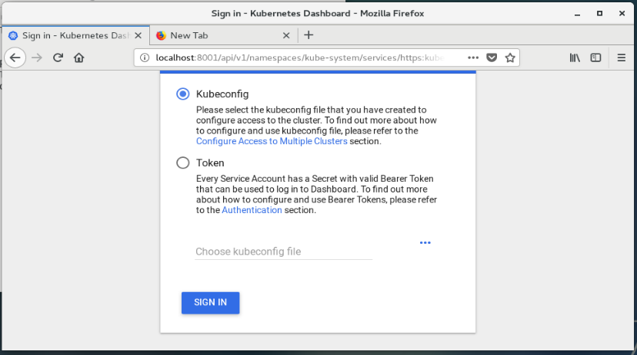

**[STEP#4] kubectl -n kube-system get secret[STEP#5] Find deployment-controller-token-XXXXX**

**[STEP#6] kubectl -n kube-system describe secret deployment-controller-token- XXXXX**

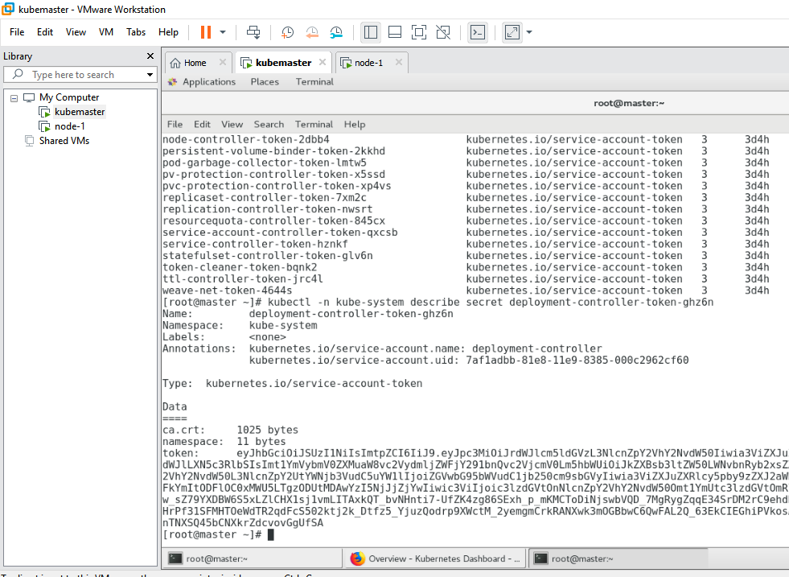

The token gets generated. Use this token to login into the dashboard.

